Professional Development Committee Meeting
March 22, 3 – 4:30 p.m., FM110
- In attendance: Kintay Johnson, Dan Calderwood (via telephone), Laurel Watson, Tatiana Robinson, Connie Carlson, Teresa Daigneault, Wendy Riggs, Rory Johnson (via telephone), Crystal Morse & Kerry Mayer.

- Absent: Mark Bernards, Johanna Helzer

- Call to order: 3:07pm

- Review/Approve Minutes of February 23 Professional Development Committee Meeting
  - Minutes are very beautiful! Thank you Crystal Morse!

- PDC Work Flow – Updated Chart
  - PDC work flow chart is very beautiful! Double THANK YOU Crystal Morse!!
  - “Report out to Academic Senate, Executive Leadership, Constituent group leaders” added to the bottom of the chart
  - No additional updates suggested

- Debrief Recent Professional Development Offerings Since Last Meeting
  - (2/24) Effective Communication for Managers by Kerry Mayer, Lisa Sayles and Crystal Morse
    - Laurel attended and said it was excellent
    - Diverse group with varying experience levels participated
    - High scores, with the only suggestion being that more time was needed because it was so awesome
  - (2/25) Advanced Canvas Training by Reno Giovannetti
    - This was double-booked with the district’s IBA training, so there were only 2 people in attendance. However, these were two HAPPY people, who had Reno all to themselves.
    - Another training with Reno coming up this week
  - (2/26) Effective Communications for Classified by Kerry Mayer, Lisa Sayles and Crystal Morse.
    - 15 people attended
    - Complaints: The room was cold and more time was needed.
    - Lots of positive comments, including suggestions that the session be required.
  - (3/4) Active Shooter Training at DN
    - This session doesn’t have data back yet.
  - (3/11) Brown Bag Book Discussion Between the World and Me by Ta-Nehisi Coates Kintay Johnson and Bill Allison facilitated
    - Good turnout
    - High ratings
    - DN will have their own session in April
  - Future sessions suggested:
    - More brown bag discussions
    - Email etiquette
    - Problem solving

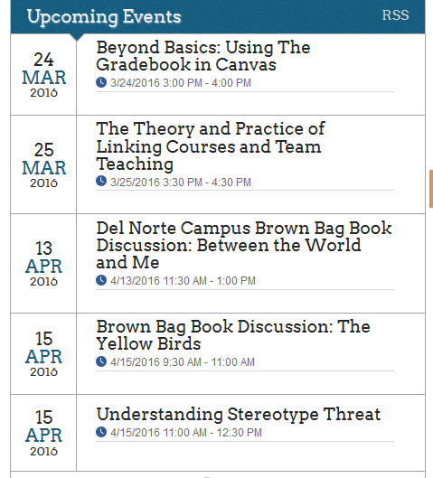
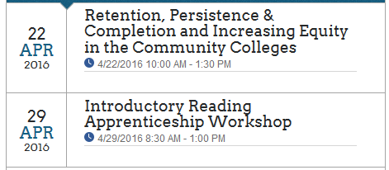
- Review Calendar of Upcoming Professional Development Offerings
  - Committee members were encouraged to share these upcoming offerings with their peeps. Kerry will put PDC members on all email distribution lists FYI.
  - Some planned events will be moved to summer, because of time. These include conflict management and a CSEA gig.
  - There was some discussion that the current manager training around conflict management is not the best training, as it is negative and legal-focused.

- PDC Website Update
  - Johanna, Crystal, and Kerry have access to editing this page.
  - It is much too difficult to find the professional development page. It should be one of the first links after clicking on “faculty resources” from the home page.
  - Kerry and Crystal with contact Johanna and encourage her to request that Brian make this change.

- Next Steps
  - Summer
    - Do additional classified and staff PD in June, including Excel Part II and additional management and CBA trainings.
    - Strengths inventory ($10 each) might be a valuable tool for managers. A couple of small group sessions around this topic could be helpful. Kintay suggested Myers Briggs instead and will send info to Crystal and Kerry.
    - Crystal will reach out to Children’s Center peeps to be sure they are included in the summer offerings
  - Long term
    - Conduct a professional development survey during AUGUST to plan for professional development opportunities for 2016-17. Previous surveys will be evaluated at the next meeting.
    - What will happen with the PDC? Crystal and Kerry have been asked to continue for another year.
  - Convocation- who is in charge? This is not a PDC event. Crystal and Kerry will bring this up in their next Keith/Mark meeting.
- Questions/Comments
- Set next meeting date: 4/26 3pm FM110
Meeting adjourned at 4:10pm

