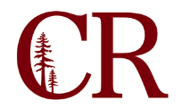
Institutional Effectiveness Committee
February 20, 2020
3:00pm – 4:00 pm

Agenda Items:
- 2019-2020 Annual Plan update
- Set IE Summit date & theme – Guided Pathways/Metamajors
- 2020-2021 Annual Plan
  - Ed Master plan?
  - Program review actions
  - Unfinished 2019-2020 annual plan items
  - ILO 3 / ILO 1 actions
  - Planning committee items (senate, CSEA, DE, etc)
- Update Committee Digest

Future Agenda Items

Adjourn

