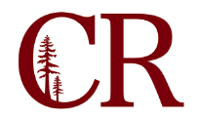
Institutional Effectiveness Committee
April 18, 2019
3:00 pm – 4:00 pm
SS-104

Agenda Items:
- Review latest iteration of Vision for Success goals (attachment)
- Review IE Summit results (attachment)
  - Add anything to Annual Plan?
- Review Annual Plan (attachment)
- Assess Institution-set Standards
  - https://public.tableau.com/profile/joseph.hays#!/vizhome/InstitutionalEffectivenessScorecard/InstitutionalEffectivenessScorecard
- Committee Self-evaluation
- Establish committee appointments and schedule for 2019-20
Adjourn

