English 1S success inquiries: March 2020-September 2020
This document is fairly unattractive. It is the easiest way to show this information quickly as an attachment, but I know it is ugly. My apologies! --Nik

March 2020
In response to the Data Joe sent in March 2020 (next page), I sent Joe these questions to better support a dialogue with English faculty.

- What does this table suggest about the current placement process we have for English 1A?

- What does this table suggest we could do better to help students make enrollment decisions between English 1A standalone and 1A + 1S?

- What does this suggest about students enrolling in 1S as compared to standalone 1A?

- What does this suggest about the specific needs or challenges of 1S students as compared to 1A students?

- What additional questions might we need to ask as researchers or as faculty to better serve our students based on this information?

Joe replied:
As usual, you’re asking the right questions. I’m not sure I have the best answers to what the observations in that table imply, but I’m more than happy to participate in the discussion. I’ll have to spend some time looking at the data through the lens of these, and similar, questions and get back to you with some ideas.

I might be able to contribute immediately by noting that this analysis does not make any causal inferences. In other words, we can’t conclude that the English 1A support course causes lower success rates, only that success rates were indeed lower (for some undetermined reason), and unlikely due to chance.

Here’s an example: Say you have ten quarters in your left hand, and another ten in your right hand. You shake the quarters around in your hands a bit and then drop them onto the table and count the number of “heads” from each hand. An analysis shows that the quarters dropped from your left hand were statistically significantly more likely to land heads up than were the quarters from your right hand. What does it mean? Does it mean all left hands make quarters land heads up? Or just your left hand? Does it mean you had heads-on-both-sides quarters in your left hand? Inversely, maybe right hands make quarters land tails up? Maybe the p-value was 0.05, meaning there’s a 5% chance of that happening with fair quarters and this just happened to be one of those 5 out of 100 cases. The answer: We don’t know why, but the statistically significant difference means there’s likely a phenomenon worth looking into – which is why I’m glad you’re asking these questions.

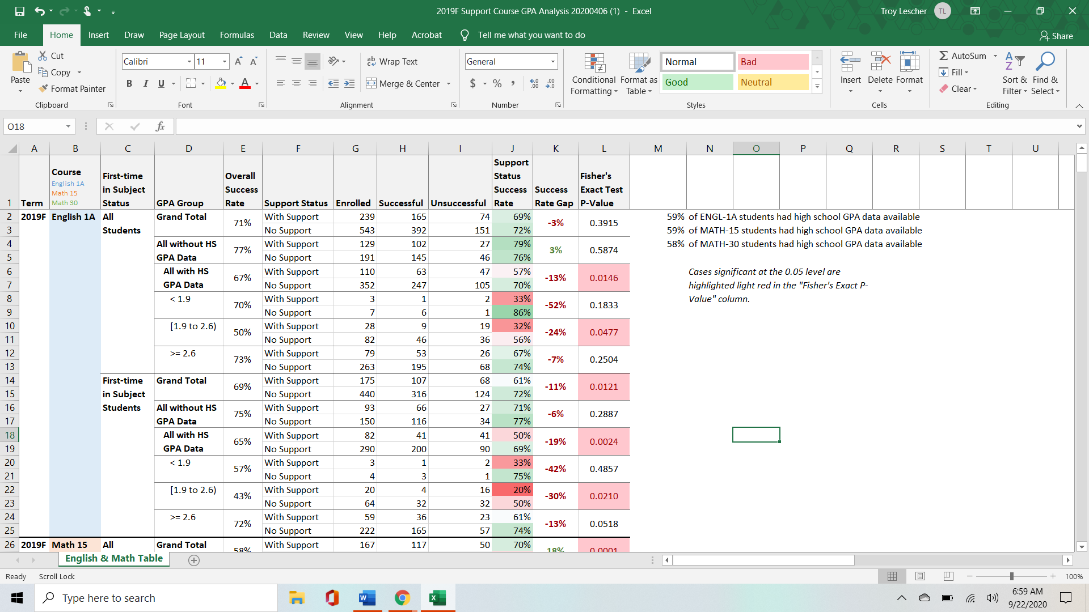

March 2020 data table
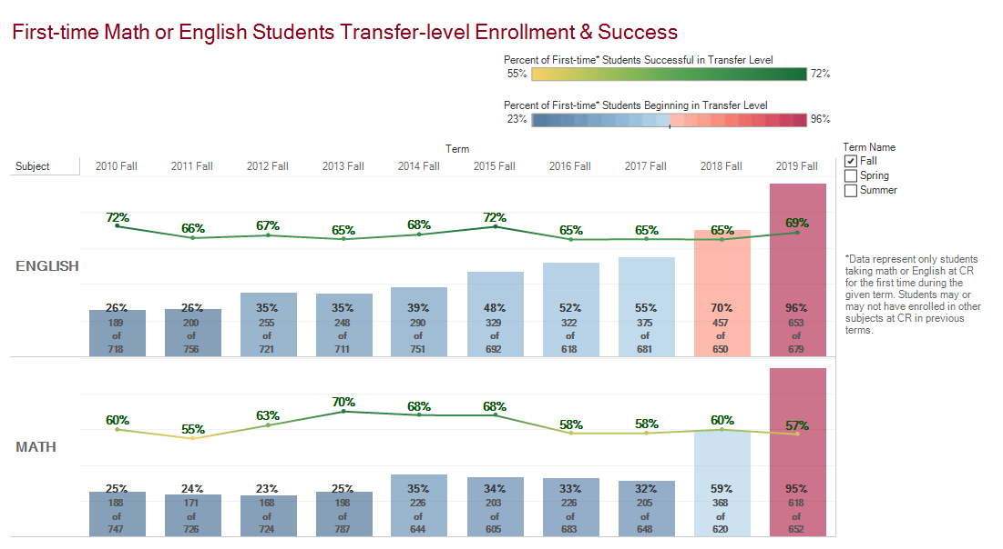

April 2020
Joe returned a separate data request I had made in March on first time student transfer level enrollment and success over the past 10 years.
Here’s a chart showing the percentage of first-time math or English students beginning in transfer-level over the past several fall terms (vertical bars in the chart), with their success rates in those courses overlaid (the line in the chart). Look at English! 96% of students starting the English sequence began in English-1A or English-1B last semester, and overall success rates went up from the previous fall term

August 2020:

I reviewed the March data again and placed a new request for Joe to further disaggregate the March data by GPA range:

below 2.0
2.0-2.3
2.3-2.7
2.7-3.0
3.0-3.3
3.3-3.7
3.7-4.0

September 2020:
Joe sent me several tables and a much more in-depth analysis of 1A and 1S successes, by campus site and disaggregated by race/ethnicity and GPA range. I am in the process of writing up this information to place into the program review. This in-depth analysis more clearly identifies places that need focus and next-step questions for the English Department to consider and research. I will share this information with the GP committee in October.

