Education Master Planning Input:
Students & Employees
College of the Redwoods
April, 2016
Results of the 3 Faculty and Staff focus groups, and 75 student questionnaire responses (obtained at two table events) were recorded and coded in the qualitative software tool NVivo. The following highest-level areas emerged. Source references the focus group or table event from which the information came.

Faculty & Staff Focus Groups 3.25.2016

Student Input 4.6.2016
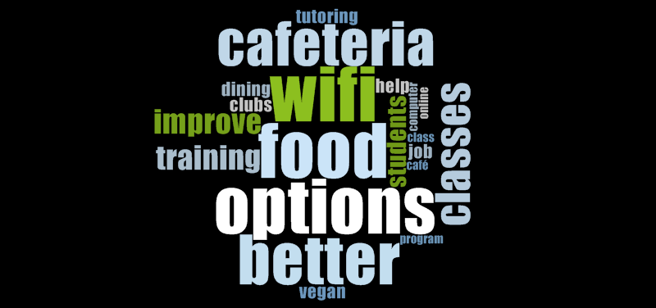
The following highest-level areas emerged. Source references the focus group or table event from which the information came.
Name | Sources | References
Technology | 6 | 58
Student Services | 6 | 42
Cafeteria | 3 | 30
Enhancing Student Success | 5 | 19
Communication | 4 | 16
Adult Education | 3 | 14
Environmental Sustainability | 5 | 14
Program and Course Offerings | 3 | 14
Infrastructure Sustainability | 3 | 10
Community Outreach | 3 | 8
Marijuana Impact | 2 | 8
Athletics | 1 | 6
Embracing Diversity | 4 | 6
Operational Sustainability | 2 | 6
Clubs and Events | 2 | 5
Health and wellness | 3 | 5
Professional Development | 3 | 5
Study areas | 1 | 1

Areas by hierarchy (indented are subareas) | References
Adult Education | 14
Athletics | 6
Pool | 3
Cafeteria | 30
Clubs and Events | 5
College Hour | 2
Communication | 16
Community Outreach | 8
Access & Marketing | 32
Forming Partnerships | 7
Embracing Diversity | 6
Enhancing Student Success | 19
Learning community | 3
Pathways | 7
Environmental Sustainability | 14
Health and wellness | 5
Safety | 3
Smoking | 2
Infrastructure Sustainability | 10
Marijuana Impact | 8
Operational Sustainability | 6
Enhance revenue | 1
Increased Personnel | 5
Professional Development | 5
Program and Course Offerings | 14
Fine Arts | 2
Honors Program | 3
More classes | 9
Student Services | 42
ASC Library | 2
Career or Life Training | 8
Childcare | 1
Early alert system | 3
Help for Economically Disadvantaged | 5
One Reg | 2
Safe space | 5
Tutoring | 3
Study areas | 1
Technology | 58
Computer labs | 3
Distance Education | 8
Wifi | 17

Areas by frequency (indented are subareas but hierarchy is not maintained) | References
Technology | 58
Student Services | 42
Access & Marketing | 32
Cafeteria | 30
Enhancing Student Success | 19
Wifi | 17
Communication | 16
Adult Education | 14
Environmental Sustainability | 14
Program and Course Offerings | 14
Infrastructure Sustainability | 10
More classes | 9
Community Outreach | 8
Marijuana Impact | 8
Career or Life Training | 8
Distance Education | 8
Forming Partnerships | 7
Pathways | 7
Athletics | 6
Embracing Diversity | 6
Operational Sustainability | 6
Clubs and Events | 5
Health and wellness | 5
Increased Personnel | 5
Professional Development | 5
Help for Economically Disadvantaged | 5
Safe space | 5
Pool | 3
Learning community | 3
Safety | 3
Honors Program | 3
Early alert system | 3
Tutoring | 3
Computer labs | 3
College Hour | 2
Smoking | 2
Fine Arts | 2
ASC Library | 2
One Reg | 2
Enhance revenue | 1
Childcare | 1
Study areas | 1

On April 6, 2016 students were asked to place a sticker on what they think should be the college’s top priorities for the next five years. Each student placed three stickers. They could put them all in one area or spread them out.

Group 1 was surveyed outside near the cafeteria and bookstore at 11 to 1 pm.
 | Count
 | 52
Dining Hall | 25
Diversity, Inclusion & Equity | 25
Job Training | 21
Classroom Tech. | 19
Athletics | 18
Online Courses | 16
Tutoring | 11
Computer Labs | 10
Clubs | 10
Classrooms | 7
Marketing/Image | 6
Honors | 4
Residence Halls | 4
Fine Arts | 3
Space to Hang | 0

Group 2 was surveyed on the quad near sciences and humanities from 2:30 to 4:30 pm.
Area | Count
Job Training | 16
Wifi | 14
Classroom Tech. | 7
Fine Arts | 7
Athletics | 6
Computer Labs | 6
Diversity Equity & Inclusion | 5
Clubs | 5
Dining Hall | 4
Tutoring | 4
Honors Program | 3
Online Courses | 3
Residence Halls | 3
Classroom Facilities | 1
Marketing/Image | 0

