Program Review Committee
November 17, 2017
9:00 am – 11:00am
SS-104
Minutes
Participants: Purpose:
Outcomes:
1. | CALL MEETING TO ORDER | - Brady Reed called meeting to order  - Philip Mancus discussed that the assessment rubic doesn’t match the planning template tab. This could cause confusion for the author. The committee agreed and recommended that the following change be made to the template for next year:  - Move and retitle the column “Relationship to Previous Assessment” before “Expected Impact.”  - The committee also wanted to add the ability to add hyperlinks within the template.
2. | REVIEW/APPROVE 10/27/2017 NOTES | - Minor typo in 3.2  - Notes approved with correction
3. | ACTION ITEMS: | - The committee reviewed, discussed and revised comments to the following templates:  - Advising/Counseling  - ASC  - Athletics  - Child Development Center  - DSPS  - Enrollment Services (Admissions, Financial Aid)  - Library  - Special Programs (EOPS/CARE)  - CalWORKs  - Upward Bound  - TRIO-Eureka  - Veterans  - Residential Life  - The committee discussed at length the assessment cycle for Student Services. The college has moved over to a 4 year cycle however many of the student services areas are on less, some every year. George P. wanted to make the authors aware that maybe they do not need to assess so often, and if they did maybe their assessments would be less meaningful.  - The committee would like Paul Chown to remove Section 6 Resource Request under the PRC feedback tab.  - The committee would like to see a drop down for the “Relations to Institutional Plans” this could help the authors.
4. | NEXT WEEKS REVIEW ASSIGNMENTS: | 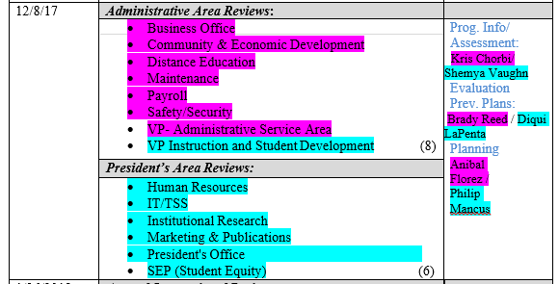
5. | OTHER/FUTURE AGENDA ITEMS | - Adjourn @ 11:02

